CN Lab # 11
21F-9136
Ayesha Zahid
Section 6E
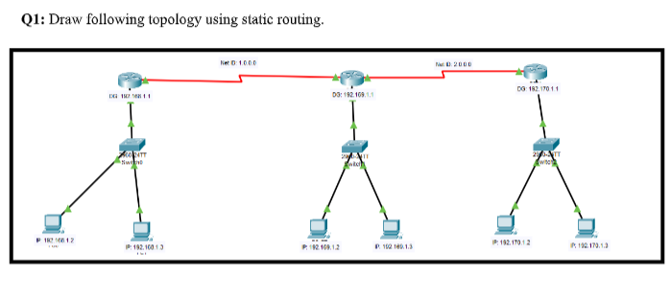
First => off the switch put wic-2T in the box on the switch on all the routers
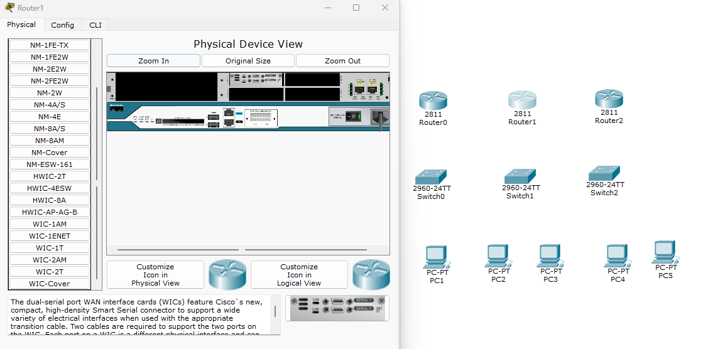

2nd => connect routers with serial dce
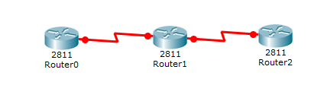
3rd => connect routers with switch -> switch with pc
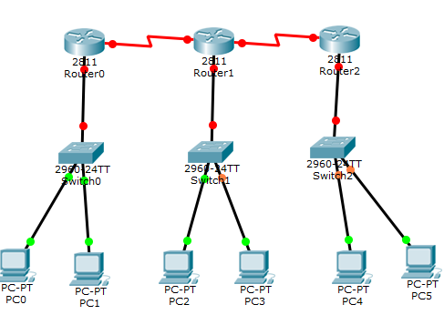
4th => change the name of all the routers
Router 1) uae
Router 2) pak
Router 3) japan
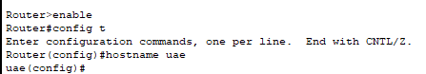

Going in interface
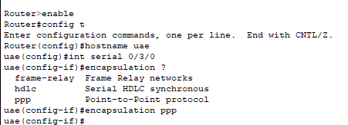
Assigning bandwidth and ip
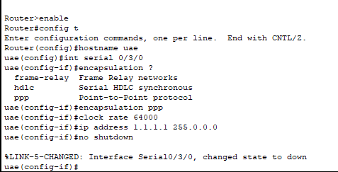
Router 2)
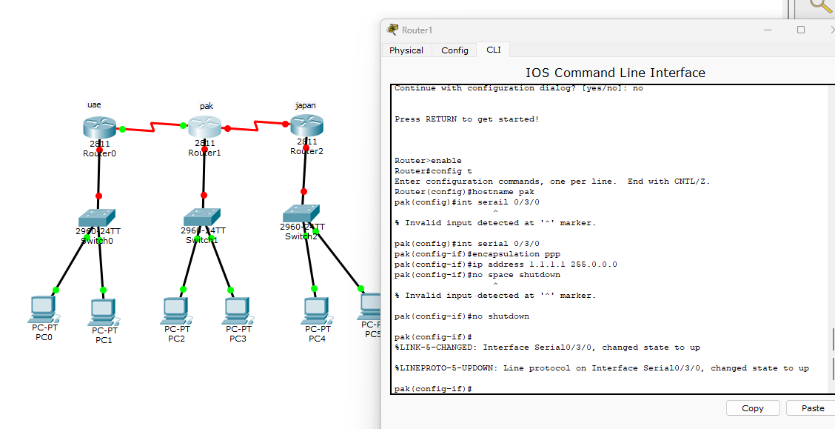
Router 3)
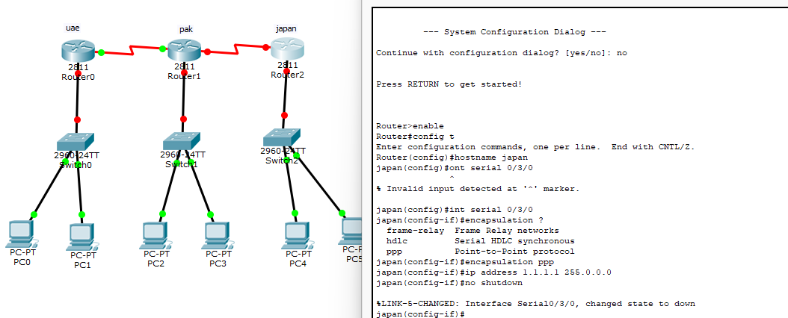

5th =>Assigning networks whole network id
Router 1)
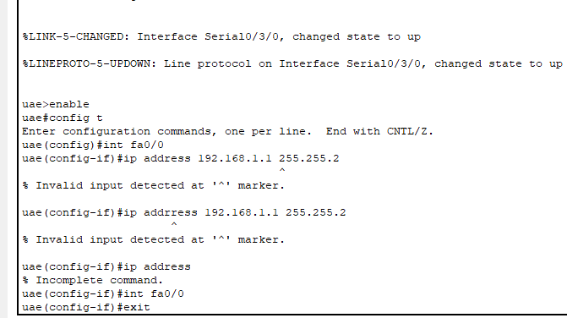
Router 2)
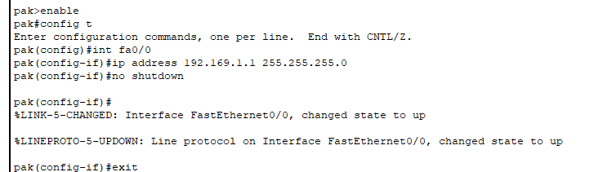
Router 3)
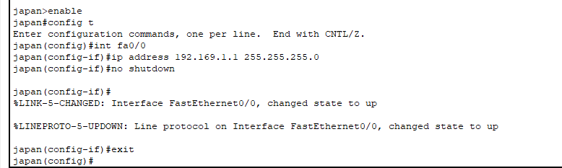

6th => Assigning Router’s other Network Id’s
Router 1)
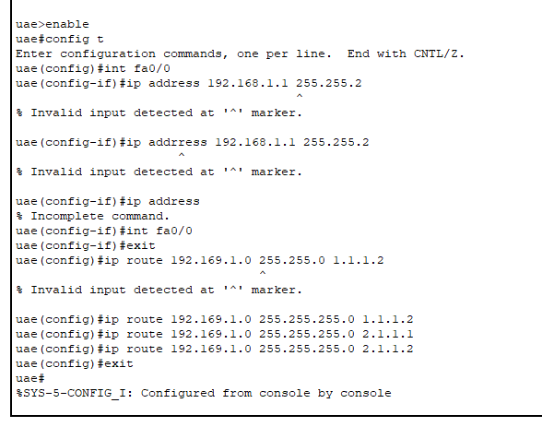
Router 2)
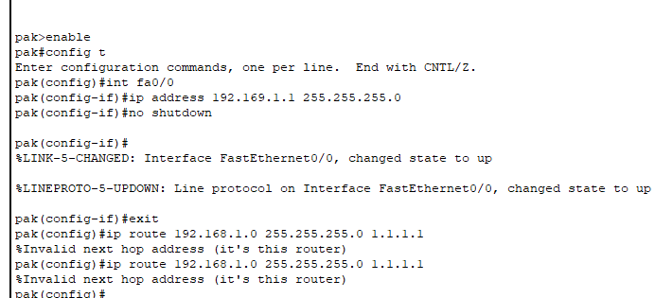
Router 3)
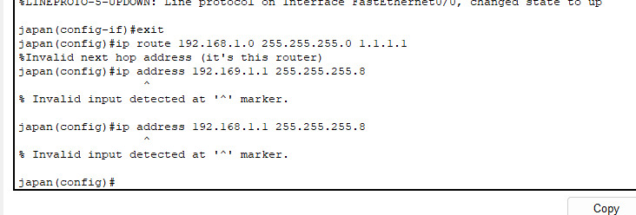
Final topology
